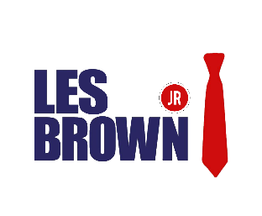
Not an Offer to Purchase or Sell Securities. This overview is for informational purposes only and is not an offer to sell or a solicitation of an offer to buy any securities in Brown Honor Inc. and may not be relied on in connection with the purchase or sale of any security. Any offering or solicitation will be made only to qualified prospective investors pursuant to a confidential offering memorandum, and the subscription documents, all of which should be read in their entirety.

“A new generation of self-improvement experts will have to emerge as technology is shifting how gurus distribute their advice to consumers. - Marketdata enterprises
MARKET OPPORTUNITY: Due to rapid advances in technology, motivational consultants who once dreamed of impacting large groups from the stage must transition into teaching and training global audiences from the cloud. The self-improvement market is forecast to post 5.6% average yearly gains from 2019 to 2022, when the market should be worth $13.2 billion. What’s even more exciting, is that there is no dominant Learning Management System, produced by & for the coveted “Millenial” generation. Still focused primarily on Baby Boomers, there are very few major motivational speakers that have emerged to serve a younger shifting demographic, leaving a huge untapped market….. Until Now!!!
Team Les Brown Jr is devoted to producing high quality content and services aimed at facilitating career advancement and life fulfillment. Within 5 years, we will inspire a minimum of 2.1 million students to participate in our three-month online course. All while vetting them, and enrolling them in an ongoing relationship that allows us to monitor and measure their results.

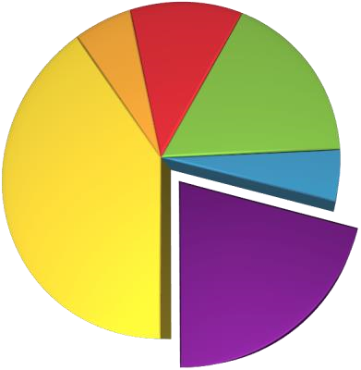
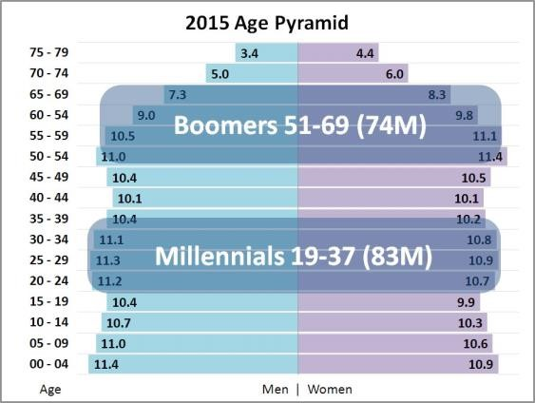

Infomercials

Speakers
Coaching
Books
CDs
Health/Weight Loss

Source: Marketdata estimates & forecasts
Besides the $150 Billion infomercial industry, there are new forms of content delivery which have emerged in the past decade including: digital downloads, video-on-demand, online subscriptions, virtual summits, mobile devices, webinars, online courses, & more.

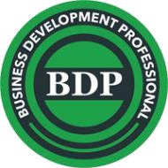
These channels only enhance our company’s overall mission of producing
& delivering high-quality original content designed to inspire, motivate & educate our customers, while providing exclusive access to the best health, wealth & self-development products & services available.
COMPANY DESCRIPTION: Brown Honor Inc™ was founded in 2017 by Les Brown Jr, CEO of Brown Honor Inc (BHI); an Orange County Motivational Speaking & Professional Development Company. To date, BHI has invested approx. $500,000 to develop, produce & perfect this unique brand of lifestyle entertainment. Upon completion of the feature-length documentary, “The IYT Movie” (It’s Your Time), Mr. Les Brown Jr assembled an award-winning team of producers, marketers & financial managers to assist with the completion of his original vision.
Brown Honor Inc™ is now positioned to launch a subscription-based High-Definition online academy. In order to reach the masses, we will produce a series of captivating commercials & half-hour infomercials and reach new consumers through paid broadcast television, cable and satellite channels, as well as internet, joint-marketing, educational, and retail distribution partners.
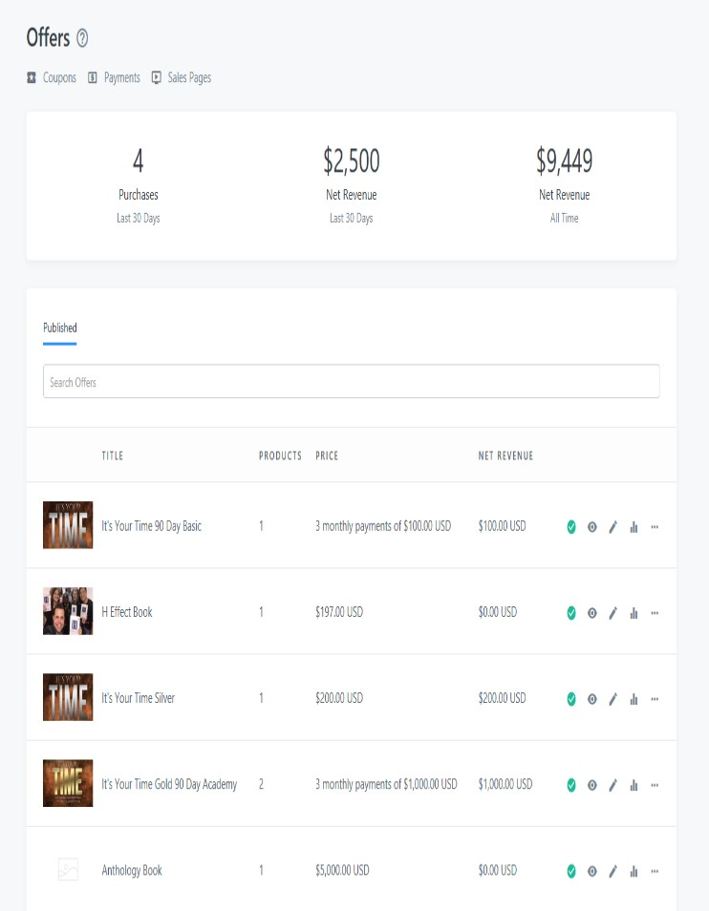
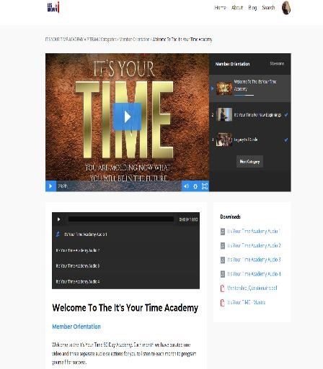
SCALABLE OPPORTUNITY: Rather than produce a series of television episodes, and sell them once to a network for distribution, we have the creative control & scalable air-time needed to ensure our company’s rapid growth & profitability. TV viewers are constantly bombarded by media & pop-culture messages that are mostly negative in nature. This is our opportunity to build a global brand that delivers positive content & valuable affiliate resources, into the homes & lives of people who need it now.

PROJECTED REVENUE STREAMS:
- Motivational Apps & Fashion Tech
- Sponsorship
- Affiliate & J/V Marketing Partners
- Embedded Sponsors per/episode
- Music, Merchandise & Apparel
- Les Brown Jr LIVE! “It’s Your Time” tour
- Corporate & Celebrity Coaching
- Online Courses & Masterclasses
- Certifications & Virtual Summits
- Books/ Keynote Speeches / Seminars

www.LesBrownJr.com

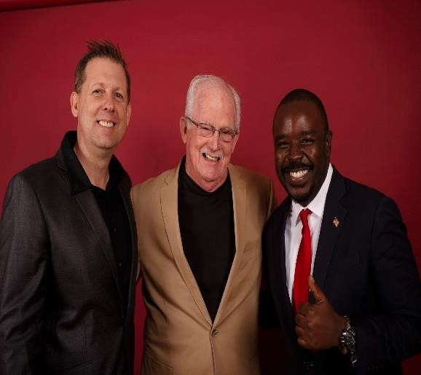
Advisory Board

Les Brown Jr is a philanthropist, the inventor of Leader Lenses and the International Best-Selling Author of Harvard Effect. His job is to become the most prominent inspirational voice online within 5 years. As soon as Les Brown Jr. met Brett Labbitt, they immediately made plans to build a global achievement driven tribe.
Brett Labbitt Tom Gay Les Brown Jr.
There was just one missing link that was absent. As a relationship genius Mr. Labbitt introduced LBJ to Tom Gay, and the trinity of synergy started bursting with every strategy session. Mr. Gay was honored in an Individual Investor Magazine cover story (May 1999) where he was called one of the "5 Best Undiscovered Small Company CEO's" in the USA.
Together these three amigos will lead the way towards a rapid profit for our share holders, sponsors, and affiliates.
MANAGEMENT TEAM: (see business plan for complete list)

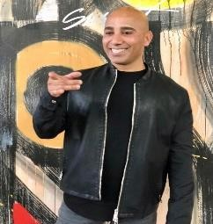

Deborah Ferris CMO: Ms. Ferris aka Ms. Linkdin is in the top 1% of viewed profiles on Linked in and will be managing Brown Honor Inc’s Speaking opportunities, workshops and corporate keynote engagements. With her leadership, Les Brown Jr will use Linkdin as a field to pick and choose our ideal alliance partners.
ADDITIONAL MATERIALS:

Pilot Episodes / Web

Portal

Business Plan, Financials

Private Placement Memorandum

To learn more about this
opportunity, contact:

1
-
3
23
-
9
03
-
7
648

support@lesbrownjr.com

www
.
le
s
brownj
r
.c
o
m

Riadh Hamdi, Sales Director:
Mr. Hamdi is a mega influencer with nearly 300,000 followers online through Instagram alone. He will be solely committed to overseeing the sales objectives are being met expeditiously and measuring how marketing efforts impact
the bottom line on a day to day basis. Connecting passion with speed and grit, Riadh came to America with only two dollars in his pocket when he arrived.
His gift is converting contacts into contracts and turning followers into family members.



Tom Jurgensen Corporate Attorney: Mr. Jurgensen is a strategist, attorney and entrepreneur with over 21years of experience in business strategy, corporate formation, fundraising, corporate partnering, business development and intellectual property in a wide variety of industries, including life sciences, consumer products, high technology and
professional services. He has deep legal experience in Corporate and Securities Law, Intellectual Property, Dispute Resolution and all varieties of Agreements.

FUNDING STRATEGY:
Development Stage: $700k in Self-Financing (completed)
First Round : National Tour & New Production : $535,000 in Preferred stock
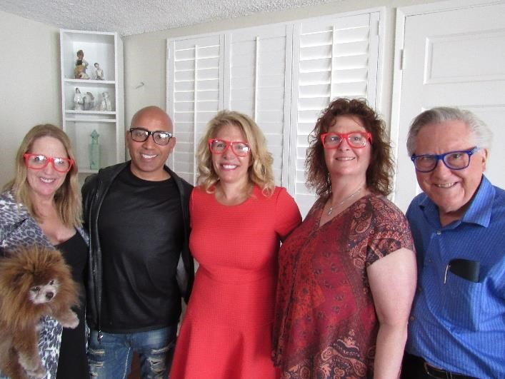
Second Round: Operations + National Campaign Launch: $3-5 million in angel funding

